IIIT Chittoor, Sri City.

Theory of Computation – Mid2

ToC – 2016m – Mid2 – Max marks = 25; Duration = 90 Minutes.

Note: This is a closed book exam. Ordinary calculators are allowed. Unclean answers can attract –ve marks.

1. How is that you can find out that the given CFG generates an infinite cardinality language or not? Give an algorithm and prove its correctness. {Your answer should be a mathematically valid one. Simply writing stories will straightaway get zero marks (may get –ve marks also) }
2. Consider the given PDA. Using an appropriate diagram of Instantaneous Descriptions (IDs) find out whether the string 1011 is in the language of the PDA (by final state) or not.

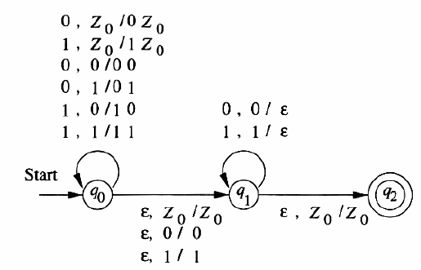

1. Give context free grammar (without $ϵ$- productions, unit productions, useless symbols) for each of the languages described below. Use $Σ=\{0,1\}$. Use S as the start symbol. For other variables use the symbols A, B, C, …
 $\{w∨w\text{contains at least two}1\text{s}\}$

 $\text{\backslash \{}w\text{|}\text{the length of }w\text{ is odd\backslash \}}$

 $\{w∨w\text{is a palindrome and length of w is atleast 1}\}$

$\text{\backslash \{}w \text{|} w\text{ starts and ends with the same symbol\backslash \}}$

1. The empty set.

------The End------